Rajalakshmanan C

E0219054

1.arrayinserting

<!DOCTYPE html>

<html>

    <head>

    <title>

        Day2 insertion

    </title>

    <script>

        var myArray=new Array();

        myArray.push("hai",10);

        z=myArray.length;

        console.log(myArray);

        console.log(z);

    </script>

</head>

</html>

Output:

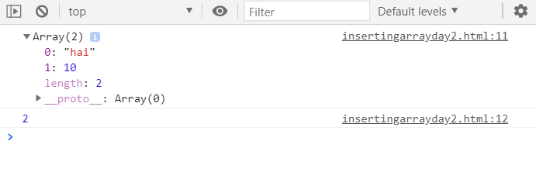

2.arratyinsertion using splice

<!DOCTYPE html>

<html>

    <head>

    <title>

        Index 10

    </title>

    <script>

        var myArray=new Array();

        myArray.push(1,2,3,4,5,6);

        myArray.splice(10,0,10);

        z=myArray.length;

        console.log(myArray);

        console.log(z);

        myArray[11]=20;

        y=myArray.length;

        console.log(myArray);

        console.log();

    </script>

</head>

</html>

Output:

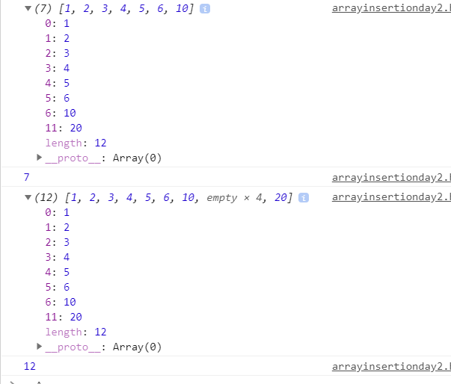

3.prime number:

<!DOCTYPE html>

<html>

    <head>

    <title>

        Prime number

    </title>

    <script>

function prime(){

    var pn=prompt("enter a number");

    var flag =true;

    for(var j=2;j<(pn/2)+1;j++){

        if (pn%j == 0){

            flag=false;

            break

        }

    }

        if (!flag){

            alert(pn + " is not a prime number");

            console.log(pn+" "+"is not prime number ");

        }

        else{

            alert(pn+ " is a prime number");

            console.log(pn+" "+"is a prime number ")

        }

    }

    prime();

    </script>

</head>

</html>

output:   
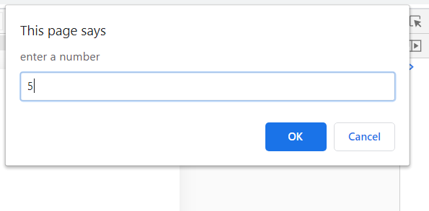

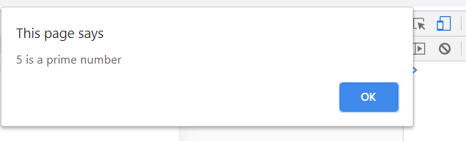

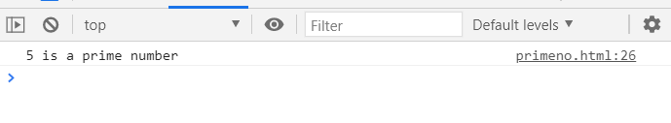

4. <!DOCTYPE html>

<html>

    <head>

    <title>

        College

    </title>

    <script>

        var clg={

            name:"SRET",

            address:"porur"

        }

        function arg(f){

            console.log(f);

        }

        arg(clg);

    </script>

</head>

</html>

ouput:

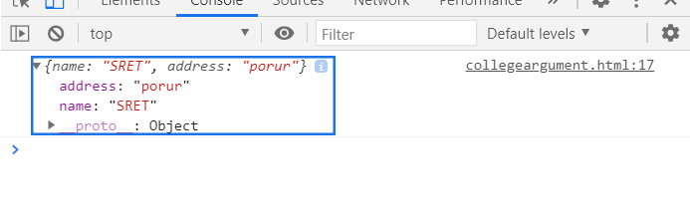

5.For of:

<!DOCTYPE html>

<html>

    <head>

    <title>

        For of

    </title>

    <script>

       const array1 = ['a', 'b', 'c'];

       console.log("For of");

    for (const element of array1) {

        console.log(element);

            }

            console.log("For in place of for of");

    for (const element in array1) {

        console.log(element);

            }

    </script>

</head>

</html>

Output:

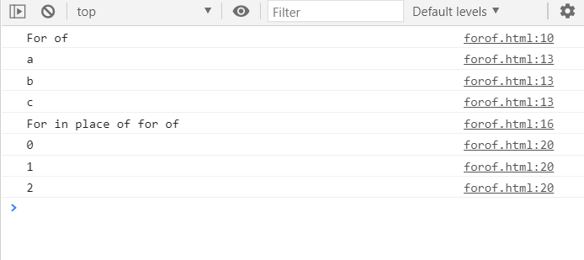

6.for in:

<!DOCTYPE html>

<html>

    <head>

    <title>

        For In

    </title>

    <script>

        const object = { a: 1, b: 2, c: 3 };

        console.log("For in");

        for (const property in object) {

        console.log(`${property}: ${object[property]}`);

            }

            console.log("Forof inplace of Forin");

            for (const property of object) {

        console.log(`${property}: ${object[property]}`);

            }

    </script>

</head>

</html>

Output:

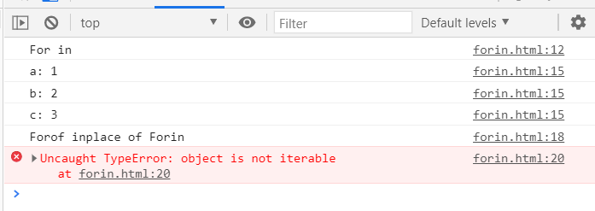

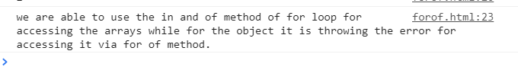

7.fruits,floers problem:

<!DOCTYPE html>

<html>

    <head>

    <title>

        Challenge 8.1

    </title>

    <script>

      var myshop={

          fruits:['apple','banana','grapes'],

          flowers:['rose','lotus','jasmine']

      }

      var i=0;

      console.log("FLowers available in the shop");

      for (i=0;i<myshop.flowers.length;i++){

          console.log(myshop.flowers[i]+"  ");

      }

      console.log("Fruits available in the shop");

      for (i=0;i<myshop.fruits.length;i++){

          console.log(myshop.fruits[i]+"  ");

      }

    </script>

</head>

</html>

Output:

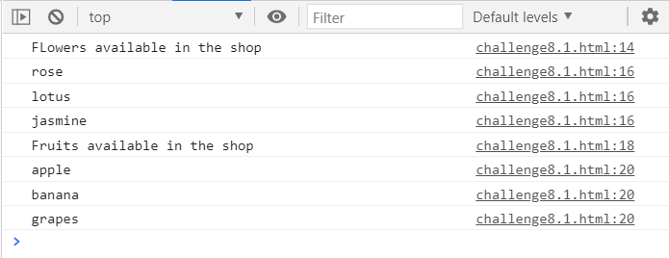

8.Script2.html

<!DOCTYPE html>

<html>

    <head>

    <title>

        Day2 insertion

    </title>

    <script>

        var John =[89,120,103];

        var Mike=[116,94,123];

        /\* 1.avg\*/

        console.log("1.Average finding")

        function avg(l){

            var sum=0;

            for(var i in l){

                sum +=l[i];

            }

            return sum/l.length;

        }

        console.log("John's average is :"+avg(John))

        console.log("Mike's average is:"+avg(Mike))

        /\*2.\*/

        console.log("Comparing the Averages");

        function com(){

                if(avg(John)>avg(Mike)){

                    console.log("John"+" "+avg(John)+" "+ "average is higher so John is Winner");

                }

                else{

                    console.log("Mike"+" "+avg(Mike)+" "+ "average is higher so Mike is Winner");

                }

        }

        com();

        /\*3.\*/

        var newJohn=[116,94,123];

        var newMike =[89,120,103];

        console.log("John's average is :"+avg(newJohn));

        console.log("Mike's average is:"+avg(newMike));

        function com2(){

                if(avg(newJohn)>avg(newMike)){

                    console.log("John"+" "+avg(newJohn)+" "+ "average is higher so John is Winner");

                }

                else{

                    console.log("Mike"+" "+avg(newMike)+" "+ "average is higher so Mike is Winner");

                }

        }

        com2();

        console.log("Comparition Of 3 members");

        var Marry=[97,134,105];

        console.log("Marry's average is :"+avg(Marry));

        function compa()

        {

            if(avg(Marry)>avg(Mike)&& avg(Marry)>avg(John) ){

                console.log("Marry is New winner with average of:"+avg(Marry));

            }

            else if(avg(Mike)>avg(Marry) && avg(Mike)>avg(John)){

                console.log("Mike is the winner with the average:"+avg(Mike));

            }

            else{

                console.log("John is the winner with the average:"+avg(John));

            }

        }

        compa()

        var newJohn1=[116,94,123];

        var newMike1 =[97,134,105];

        var newMarry1=[89,120,103];

        function compa1()

        {

            if(avg(newMarry1)>avg(newMike1)&& avg(newMarry1)>avg(newJohn1) ){

                console.log("Marry is New winner with average of:"+avg(newMarry1));

            }

            else if(avg(newMike1)>avg(newMarry1) && avg(newMike1)>avg(newJohn1)){

                console.log("Mike is the winner with the average:"+avg(newMike1));

            }

            else{

                console.log("John is the winner with the average:"+avg(newJohn1));

            }

        }

        compa1()

    </script>

</head>

</html>

Output:

